LADIES’ AUXILIARY BOARD MEETING
SUNDAY, FEBRUARY 3, 2013 AT 10:00 AM

Please join us on Sunday February 3rd, at 10 AM for our Auxiliary Board Meeting. Please e-mail items, ideas and questions which you would like on the Agenda to ladiesaux1599@aol.com .

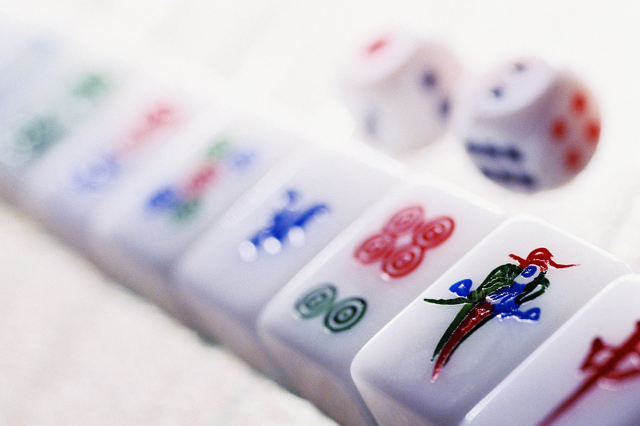

LADIES’ AUXILIARY CARD PARTY & LUNCHEON
SUNDAY, FEBRUARY 3, 2013 AT 11:00 AM
Join us on Sunday afternoon, February 3rd, for our annual Auxiliary Card Party. Get your groups together for Mahjong, Bridge. So, call your friends and reserve a table. Call the Synagogue Office for reservations at 304-346-4722 or e-mail synsecretary@yahoo.com .
Lunch will be served - cost $5.00 per person

MARY SLUTKSY MEMORIAL LIBRARY FUND
Books $15.00 – Cards $5.00 – call the Synagogue

Bobby & Robin Peck in memory of Pat Max, Harriet Masinter, Martin Muhlrad, Seymour “Bud” Hyman, Art Weisberg, Billie Schwartz, Pauline Borstein, Rebecca Zacks, Milton Diznoff, Zelig Kanner, Max Knell, in honor of the 80th birthday of Steve Meyer, in honor of Gary Kanner’s acceptance into WVU School of Medicine, in honor of Denise Winegard obtaining her licensure as a Licensed Clinical Professional Counselor in the State of Maryland, birth of Hazel Goldberg, marriage of Blair Preiser & Evan Wolfson, engagement of Sara Victorson & Adam Schwinbach, birthdays of Ruth Bloom, Ruby Newman-Peck, in honor of Chava Urecki being selected to join the Phi Beta Kappa Society, recovery of Jane Hogue, in honor of the Bar Mitzvah of Jacob Levenson, for the recovery of Barbie Sadolf, Alvin Preiser .

Dr. & Mrs. Steve Artz in memory of Lillian Cooper, recovery of Steve Meyer, in honor of the Bar Mtizvah of Evan Samuel Artz, son of Dr. & Mrs. David Artz of New Jersey (Library Books)

Page 1
AMONG OUR FRIENDS
MAZEL TOV TO:
Cary & Rosemary Levenson on the Bar Mitzvah of their son Jacob.
Margee & Stan Denver on the birth of a granddaughter, daughter of Nathan & Emily Denver, great-granddaughter of the late Judy & Stan Rubin.
Ed & Ellyn Goldberg on the birth of a granddaughter, Hazel Goldberg, daughter of Roni & Abe Goldberg of South Carolina.
Harvey & Phyllis Sherman in honor of the Bat Mitzvah of their granddaughter Mia
Stacy & Eric Snyder on the birth of a son, Isaac Snyder.
Dr. Jason & Mandy Prigozen on the birth of a daughter, Jaqueline Maya Prigozen.
Jim & Deidre Doria on the birth of a granddaughter, Nora Elizabeth, daughter of Elaina & Nolan Tully. Nora was born on October 18th.
Janet & Michael Victorson on the engagement of their daughter Sara to Adam Scheinbach. Sarah is the granddaughter of Mrs. Debbie Victorson.
Rabbi Chaim & Mindy Landau on the birth of a grandson, Adir Yoseph, son of Talia & Arnon Shorr.
Dr. Joel & Janet Cooper on the birth of a grandson, Eliot Cooper.
Jim & Deidre Doria on the birth of a granddaughter, Nora Tully, daughter of Elaina & Nolan Tully of Philidelphia.
Bob Bloom &Amy Hicks Bloom on their recent marriage.
Mrs. Pam Waybright on the birth of a granddaughter, Hannah Michelle Berman, daughter of Alex Berman & Lisa Wald.

Page 2
AMONG OUR FRIENDS(con’t)
SINCEREST TO:
Edwin “Peachy” Masinter and Richard & Judy Masinter, Michael & Maria and families on the passing of beloved wife, mother and grandmother Harriet Masinter
Michael & Theresa Schwartz, Susan & Barry Goldner, Howard & Buffy Schwartz, Barbara Schwartz and families on the passing of beloved mother and grandmother, Rose Iris “Billie” Schwartz.
Joan Weisberg, Martha & Mark Barvin, Charleston & Amanda Weisberg, Seth & Rivka Weisberg, Pamela Weisberg, Louis & Liz Weisberg and families on the passing of beloved husband, father and grandfather Arthur “Art” Weisberg.
Mrs. Emily Shrut and family on the passing of her beloved mother Bertha Romat.
Dr. & Mrs. Joel Cooper, Dr. & Mrs. Amiel Cooper and Mr. Jonathan Cooper and families on the passing of beloved mother and grandmother, Mrs. Lillian (Samuel) Cooper.
Mrs. Evelyn Ettleman on the passing of her beloved husband Ben Ettleman. Ben is the uncle of Mrs. Phyllis Kerstein Sopher.
We regret to learn of the death of Arnold Ostrin, son of the late Arthur Ostrin. He is survived by his sister Anita Solomon, cousins Linda Toborowsky and Gary Borstein
.

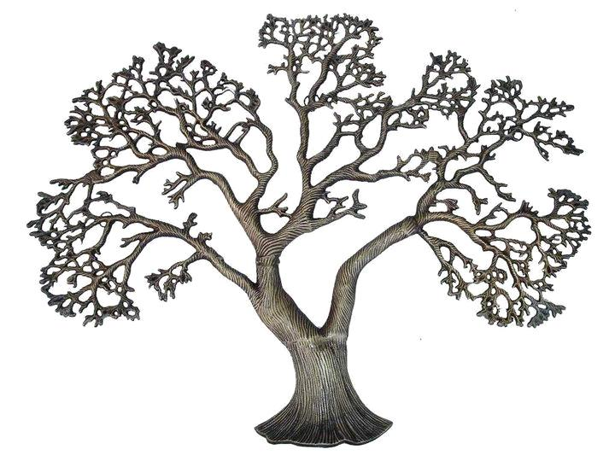TREE OF LIFE:
Jeannette Kanner, Chairperson (304-343-8579)
Leaves $100. Stones $750.00

LEAVES:

In honor of the 80th birthday of our number one friend and mentor Stephen P. Meyer Love Stuart & Susan May
November 24, 2012

“Aggie” Rubin, The best wife, mother, sister and friend – Love Pamela & Leo Gardner – 2012
Page 3
PULPIT FUND (Rabbi’s Discretionary Fund)
Contribution $5.00 – 304-364-4722

Sharan & Elliot Levy and Sondra & Paul Kulback in loving memory of father Ben L. Sniderman

Mr. Kenneth Pettry in thankfulness.

Dr. Steve & Sharon Jubeliber in honor of the birth of their grandson Jonathan Jablow.

Sharon & Steven Marshall in memory of Harriet Masinter.

Monty & Sara Preiser in memory of Huck Saxe, birthday of Steve Meyer, Linda Toborowsky on her outstanding job with Rabbi Samuel Cooper’s book, Bar Mitzvah of Oliver Baer, in memory of Harriet Masinter.

Emily Marks, Bob & Sandi Marks in loving memory of the 5th anniversary of the passing of husband and father Sydney Marks.

A SPECIAL CONTRIBUTION:

Mrs. Ruby Newman-Peck has made a special contribution in thankfulness for all the cards, contributions and good wishes for her birthday and in honor of Rabbi Victor Urecki and in appreciation for all that he has done for her.

KATHERINE & JACOB WALLACE CEMETERY FUND

A special contribution was made by Margee Denver, Bob Rubin, Nancy Newfeld and Betsy Rock & Families in loving memory of grandparents Fred & Sophia Goldman, in memory of Billie Schwartz, Art Weisberg.

Dr. Philip & Lynn Abrams

Page 4
PRAYERBOOK & PRAYERSHAWL FUND –
Contributions $5.00 – Friday Night Book $20. – Sabbath Prayerbook $30.00 –Pentateuch & Haftorah and Etz Chaim $50.00

Dr. Joseph Abrams in memory of his mother-in-law Lena Berman (Sabbath Prayerbook).

Ed & Ellyn Goldberg in honor of the birthday of Steve Meyer (Sabbath Prayerbook)

Dr. Steve & Jackie Artz in honor of the birthday of Steve Meyer (Friday Night Prayerbook)

Toby Scherer in memory of Haskell “Huck” Saxe (Friday Night Prayerbook)

Alvin & Gayle Preiser in memory of Micky Westrich (Sabbath Prayerbook)

Malcolm, Barb and Julie Silverberg, Janie & John Stutzman in memory of Harriet Masinter (Friday Night Prayerbook)

Ruth Bloom in honor of the 80th birthday of Steve Meyer (Sabbath Prayerbook)

Cookie Sloman in memory of Billie Schwartz (Sabbath Prayerbook)

Cary, Rosemary, Samuel and Jacob Levenson in honor of the 80th birthday of Steve Meyer (Sabbath Prayerbook)

Betsy & Roy Gooding in honor of the 80th birthday of Steve Meyer (Friday Night Prayerbook)

Dr. Art & Missy Rubin in memory of Arthur Weisberg (Sabbath Prayerbook)

Thelma Levine, Natalie, Marilyn, Carolyn and Debra in loving memory of Lillian Cooper (Pentateuch & Haftorah)

Cookie Sloman in loving memory of her parents Bernice & Alvin Sloman, sister Penny Sloman and aunt and uncle, Bernice & Sydney Nearman (Sabbath Prayerbooks)

Roberta Lee Levine and Richard Hess in loving memory of Lillian Cooper (Sabbath Prayerbook)

Dr. & Mrs. Steve Artz wising a safe trip back to WV to Jon & Dorothy Kurland.

Page 5
SYNAGOGUE CORNER:

Dr. & Mrs. Jonathan Arden in thankfulness and appreciation.

Dr. Steve & Jackie Artz in memory of Harriet Masinter, in honor of the 50th anniversary of Phyllis & Harvey Sherman.

Martha & Mark Barvin in honor of the 80th birthday of Steve Meyer.

Judge Duke & Carole Bloom in memory of Harriet Masinter, Billie Schwartz, and birthday of Steve Meyer

Ruth Bloom in memory of Mary Hoffman, recovery of Barbie Sadolf, Jon Kurland.

Gary Borstein, Karen Seim and Linda Toborowsky for the recovery of Linda Rubin, Jon Kurland, Hazel Crowley, Barbie Sadolf, in memory of Art Weisberg, in memory of Lillian Cooper, in honor of the birth of Eliot Cooper.

Barbara Buchanan in honor of the birth of Luna Kusminsky, birth of a grandson to Dr. Steve & Sharon Jubelirer, granddaughter to Andrea & Manie Fernendez, engagement of Dov Landau & Melissa Novella, son of Rabbi Chaim & Mindy Landau, in memory of Haskell Saxe, in honor of the birthdays of Ed Goldberg, Betty Schoenbaum.

The “Cooper Troopers” of Cooper and Cooper Real Estate in loving memory of Lillian Cooper.

Natalie & Jerry Cowley for the recovery of Jon Kurland.

Edward and Peter Eiland in memory of Abe Gordon.

Evelyn & Ben Ettleman for the recovery of Sanford Lewis.

Andrea & Mannie Fernandez in memory of beloved aunt Cleopes R. Nicdao.

Marcia & Paul Friedberg in memory of Lillian Cooper.

Norman & Ronni Glaser in memory of Samuel Glaser and in thankfulness.

Page 6
SYNAGOGUE CORNER (con’t):

Jerry & Donna Goldberg on the birth of Nora Tully, granddaughter of Jim & Deidre Doria, daughter of Elaina & Nolan Tully.

Dr. Todd, Eileen and Matt Goldberg in memory of Art Weisberg.

Doris & Jack Goldfarb in honor of the 80th birthday of Steve Meyer and for the recovery of Lynn Meyer.

Pam & Glenn Goldfarb in memory of Art Weisberg.

Dr. Phil Goldstein in memory of Drew Morton.

Mrs. Francine Greff in loving memory of her father Joseph Wolpert.

Ben & Jane Hark for the recovery of Barbie Sadolf.

Patricia Johnston in memory of Lillian Levine.

Ted & Shelley Kanner in honor of the birthdays of Jean Urecki, Ruby Peck, Steve Meyer, birth of Hazel Goldberg, grandson of Ellyn & Ed Goldberg, Adir Yoseph Shorr, grandson of Rabbi Chaim & Mindy Landau, memory of Art Weisberg.

Mr. & Mrs. Arthur Kaplansky in memory of Billie Schwartz.

Kathie & Marty Kommor in honor of the birthday of Steve Meyer, recovery of Lynn Meyer, in memory of Harriet Masinter. Billie Schwartz, in honor of the conversion of Gail Twigger-Shaw, recovery of Alvin Preiser, engagement of Sara Victorson & Adam Scheinbach

Steve Kravitz in memory of his beloved parents , Hilda & Louis Kravitz.
Jon & Dorothy Kurland for the recovery of Barbie Sadolf and in honor of the engagement of Sara Victorson and Adam Scheinbach
Cary & Rosemary Levenson & Family in honor of the birthday of Steve Meyer, Ruby Peck and Jean Urecki, in memory of Harriet Masinter, Art Weisberg.

Shirley and Etta Lee Levenson in memory of Lillian Cooper.

Page 7
SYNAGOGUE CORNER (con’t):

Roberta Lee Levine & Richard Hess in honor of the birthday of Steve Max, recovery of Barbie Sadolf.

Thelma Levine in memory of Harriet Masinter, Charles Levine, Art Weisberg, conversion of Gail Twigger-Shaw.

Zel & Sanford Lewis in memory of Harriet Masinter.

Dr. Bob & Robin Levine in memory of Harriet Masinter, Billie Schwartz.

Roberta Lee Levine and Richard Hess for the recovery of Lynn Meyer, Linda Rubin, in honor of the 70th birthday of Ed Goldberg, birthdays of Ruby Newman-Peck, Jean Urecki, Steve Meyer, in memory of Billie Schwartz, birthday of Linda Toborowsky, in memory of Harriet Masinter,

Sanford Lewis made a special contribution in thankfulness to all the members and friends who have sent good wishes for his speedy recovery

Marsha & Norman Marks in honor of the engagement of Rachel Kanner & Adam Volin and Jennifer Hoffman & Lincoln Crall, birth of Hazel Goldberg, birthday of Steve Meyer, Nancy Morton, Ed Goldberg, in memory of Billie Schwartz, Harriet Masinter, Drew Morton, recovery of Sanford Lewis

Susan & Stuart May in honor of the birth of Hazel Goldberg, recovery of Lynn Meyer, birth of grandchildren to Dr. Roberto & Liliana Kusminsky, engagement of Jennifer Hoffman & Lincoln Crall, birth of Aria Singh, marriage of Blair Preiser & Evan Wolfson, recovery of Jon Kurland, Helen Lodge, in memory of Harriet Masinter, Art Weisberg, recovery of Barbie Sadolf.

Jay & Julie Margois in memory of Drew Morton.

Marsha & Norman Marks in memory of Lillian Cooper.

Steve & Lynn Meyer for the recovery of Debbie Victorson.

Joann, Rick, Sara, Lauren and Lindsey Miller in loving memory of Billie Schwartz.

Page 8
SYNAGOGUE CORNER (con’t):

Merrill, Sandy, Davey and Zoe Nearman in loving memory of Drew Morton.

Rita & Nemo Nearman in honor of the birthdays of Jean Urecki, Ruby Peck, Steve Meyer, recovery of Lynn Meyer

Kurt & Danita Nellhaus in memory of Drew Morton.

Randi & Donn Neurman in honor of the birth of Hazel Goldberg, Meritorious Honor Award from the State Department to Sarah Goldfarb and in honor of her engagement to Jesse Thomas, recovery of Lynn Meyer, in honor of the birthday of Steve Meyer, recovery of Barbie Sadolf.

Eileen & Barry Ogrin in memory of Harriet Masinter.

Pam Pushkin in loving memory of her husband Dr. Jack Pushkin,
in memory of Harriet Masinter, Shirley Goldstein, in honor of the birthdays of Ed Goldberg and Steve Meyer, the continued recovery of Lou Goldberg, Helen Lodge and Tom Carson, and in thankfulness to B’nai Jacob and Rabbi Victor Urecki, for the recovery of Barbie Sadolf.

Stephen & Deborah Paul in memory of Harriet Masinter.

Ruby Newman-Peck in thankfulness for Mannie & Andrea Fernandez and B’nai Jacob for honoring her 92nd birthday.

Bill & Terrie Rosenfeld in honor of the birthdays of Ruby Newman-Peck, Nancy Morton, Jean Urecki, Ed Goldberg.

Aggie Rubin in honor of the birth of a granddaughter to Manie & Andrea Fernendez, engagement of Jennifer Hoffman & Lincoln Crall, Sara Victorson & Adam Scheinbach, Sarah Goldfarb & Jesse Thomas, Award of Chava Urecki, birth of a grandson to Steve & Sharon Jubelirer, memory of the mother of John Stutzman, 50th anniversary of Jackie & Steve Artz, Happy Chanukah to Betty Schoenbaum, Helen Lodge, recovery of Barbie Sadolf, memory of Haskel Saxe, recovery of Lynn Meyer.

Page 9
SYNAGOGUE CORNER (con’t):

Art & Missy Rubin for the recovery Lynn Meyer, Barbie Sadolf and Linda Rubin, in memory of Harriet Masinter, in honor of the birthday of Steve Meyer, Bar Mitzvah of Jacob Levenson, engagement of Sara Victorson & Adam Scheinbach, Jennifer Hoffman & Lincoln Crall, and in memory of her beloved father Robert Greenfield.

Barbara & Ken Rubin in honor of the birth of a granddaughter to Dr. Roberto & Liliana Kusminsky, birth of a grandson to Dr. Steve & Sharon Jubelirer, recovery of Helen Lodge and Aggie Rubin, Bar Mitzvah of Jacob Levenson, Bat Mitzvah of granddaughter of Harvey & Phyllis Sherman, engagements of Sarah Goldfarb & Jesse Thomas, Jennifer Hoffman & Lincoln Crall, and in memory of Art Weisberg.

Rick & Wendy Rubin in memory of Harriet Masinter, Art Weisberg, in honor of the 80th birthday of Steve Meyer.

Toby Scherer in memory of Harriet Masinter.

Betty Schoenbaum for the recovery of Aggie Rubin, in honor of the birthdays of Steve Meyer, Ruby Peck, in memory of Billie Schwartz, Harriet Masinter

Brian & Randy Bogard Selbe in thankfulness.

Phyllis & Harvey Sherman in honor of the birthdays of Ruby Newman-Peck, Jean Urecki, Kathie Kommor, Nancy Morton, Steve Meyer, recovery of Debbie Victorson, in honor of the engagement of Sara Victorson & Adam Scheinbach, in memory of Harriet Masinter, recovery of Phil Rubin, Linda Rubin, Lynn Meyer, 70th birthday of Linda Toborowsky, in memory of Billie Schwartz, Art Weisberg.

Malcolm, Barb and Julie Silverberg, Janie & John Stutzman in memory of Billie Schwartz, Art Weisberg.

Mrs. Betty Skaggs in loving memory of Harry Lazaroff, Flora Lazaroff, Fannie Lazaroff Lenett.

Ellen & Marc Slotnick in memory of Art Weisberg, Harriet Masinter, Billie Schwartz.

Page 10
ROB’S FUND CON’T

Barbie & Rick Sadolf made a special donation I honor of the birthday of Shelley Kanner, recoveyr of Eric Gattlieb, in honor of the promotion of Jennifer Hoffman.

Rob’s Fund donated to the Gazette and Charleston Daily Mail Christmas Funds.

SYNAGOGUE CORNER (con’t):

Phyllis Sopher, Dr. Malcolm & Pat Kerstein, Dr. Harvey & Dana Kerstein in memory of Art Weisberg.

Mr. Grover Stein in thankfulness and appreciation.

Betty & David Stern in honor of the birthdays of Steve Meyer, Ruby Newman-Peck and Jean Urecki.

Bernard and Sheldon Wolfson in thankfulness.

Mrs. Adele Wynder in honor of her grandson Joshua Synder becoming an Eagle Scout.

Doris Zagon in loving memory of her husband Harold Zagon.

Ruth S. Barton Food Fund
Kroger Cares Fundraising Program
Support our Ladies Auxiliary in this worthy cause!

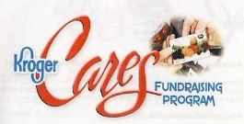
As of November 21st, the Kroger Cares cards for "The Ruth S. Barton Food Fund" became available to purchase at $5.00 each. This amount is pre-loaded on each card.

The Kroger Cares cards look like and work like a gift card. Money can be added at any time and at any Kroger store with cash, check, or debit cards. There is no minimum. Kroger credits 5% of all money to the Ladies Auxiliary/Ruth S. Barton Fund.
The cards are available and can be purchased at the synagogue office or by contacting Linda Toborowsky at ladiesAux1599@aol.com .
Page 11
ROB’S FUND Ellyn Goldberg, Chairperson 304-344-9444
(Minimum contribution $5.00)
Ed & Ellyn Goldberg in memory of Michael Allen, in memeory of the mother of John Stutzman, in honor of the birth of a great-niece, Eve Alice Jacobs, birth of a grandson to Steve & Sharon Jubelier, in honor of Jacob Stutzman receiving his PhD, in honor of the 50h anniversary of Steve & Jackie Artz, continued recovery of Lynn Meyer and thinking of Sanford Lewis, in honor of the birthdays of Jean Urecki, Nancy Morton, recovery of Jon Kurland, in memory of Harriet Masinter, in honor of the birthdays of Kathie & Marty Kommor, in honor of Jennifer Hoffman’s promotion.

Malcolm, Barb and Julie Silverberg, John & Janie Stutzman for the recovery of Lynn Meyer and in honor of the 80th birthday of Steve Meyer.

Lynn & Steve Meyer in honor of the birthdays of Jean Urecki, Gary Sheff, recovery of Jon Kurland, Sanford Lewis, Helen Lodge, Tom Carson, converion of Gail Twigger-Shaw, in honor of the 50th anniversaries of Harvey & Phyllis Sherman and Dr. Steve & Jackie Artz, Bat Mitzvah of granddaughter of Harvey & Phyllis Sherman, in appreciation to Marjot Jogwick, engagements of Dov Landau &Melissa Novella, Jennifer Hoffman & Lincoln Crall, Rachel Kanner & Adam Volin, Sarah Goldfarb & Jesse Thomas and Sarah’s Meritorious Honor Award and birthday, Carole Bloom for her Outstand Citizen Award, birthday of Ruby Peck, thinkof Barbie Sadolf with love and in memory of her wonderful mother Ruth Barton, in memory Justin, son of Michelle & Jay Miller, thinking of Rabbi Israel & Peggy Koller, birth of a grandson to Stve & Sharon Jubelirer, in honor of Chava Urecki achieving Phi Beta Kapa, marriage of Blair Preiser & EvanWolfson, in honor of birthday of Betty Schoenbaum, in memory of Harriet Masinter, in honor of the engagement of Sara Victorson & Adam Scheinbach..

Marsha Albert in loving memory of her husband, Bob Albert, birthday of her son David Pushkin, birthdays of Phil Goldstein, Marty and Kathie Kommor, Marcia Jo Zerivitz, Betsy Cohen, Lee Diznoff, in honor of the birth of a grandson to Mary Pesetsky, congratulations to Gayle Twigger Shaw on becoming a "Jewish Princess", in loving memory of Mickey Westrich, Drew Morton, Mary Hoffman

Barbie & Rick Sadolf in memory of Harriet Masinter, in honor of Roberto Kusminsky’s appointment to Chief of Surgery, birth of Hazel Goldberg, birthdays of Steve Meyer, Nancy Morton, Bar Mitzvahs of Jacob Levenson and Oliver Baer, in honor of Barrie Kaufman’s exhibit at the Huntington Art Museum.

Ellen & Marc Slotnick in honor of the birth of Hazel Goldberg.

Page 12

ROB’S FUND (con’t):

Ed and Ellyn Goldberg made a very special donation to Rob's Fund in appreciation for all the cards in honor of Ed's birthday and Hazel Ann Goldberg’s birth.

Joy & Ben Redmond for the recovery of Barbie Sadolf.

Steve & Sharon Rubin in honor of the 80th birthday of Steve Meyer, 70th birthday of Ed Goldberg, birth of Hazel Goldberg, birthday of Ruby Newman-Peck, in memory of Art Weisberg and Harriet Masinter, recovery of Barbie Sadolf.

Barbara & Ken Rubin for the recovery of Lynn Meyer and in honor of the birth of Hazel Goldberg.

Kathie & Marty Kommor in memory of Christopher Bsharah.

Jody Pruss in honor of Suzy Robbin.

Rob's Fund made a donation to a family in Sissonville who lost their home in the gas explosion.

CHANGES AND ADDITIONS TO THE 2012-13 YEARBOOK

*New Members of B’nai Jacob Synagogue:
*Aaron Bloom
1109 Edgewood Dr.
Charleston, WV 25302

*Debra Levine
208 Bradford St. #3
Charleston, WV 25301

*David Pushkin
19 Bradford St. Apt. 102
Charleston, WV 25301

*Jerry Abshire

E-mail address for Marcia Zerivitz: mzerivitz@me.com

Donna Hark (Life Member of the Auxiliary)

Page 13
CHANGES AND ADDITIONS TO THE 2012-13 YEARBOOK(con’t)
Stephanie Winston - add zip code 10003 Phone number: 212-533-8860

Dr. Bob & Amy Bloom
1582 Virginia St. E.
Charleston, WV 25311

Sheri & Kirk Brandfass
719 Castlegate Rd.
Charleston, WV 25303
sbrandfass@aol.com

Gail and Bill Carter
1396 Bedford Road
Charleston, WV 25314
304-345-2042

Ruth Elam – 327 Baker Lane

Dr. Phillip Goldstein
Kindred Kenosha South
8400 Sheridan Road
Kenosha, WI 53143/

Bob Nearman
Riverview Ret. Comm.
18801 E. Upriver Dr. Room 205W
Spokane, WA 99207
509-482-8433

Dr. Jason & Mandy Prigozen
2 Muirfield Ct.
Charleston, WV 25304

Ms.Barbara Schwartz
313 21st St. SE
Charleston, WV 25304

Janice & Paul Sherman
1733 Aqrbor Knoll Loop
Trinty, FL. 34655

Page 14

